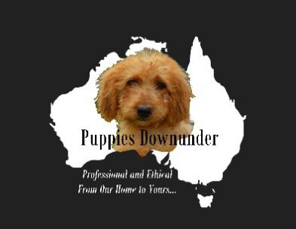Puppy Diet Guide

**Puppies Downunder**

**License No. L120**

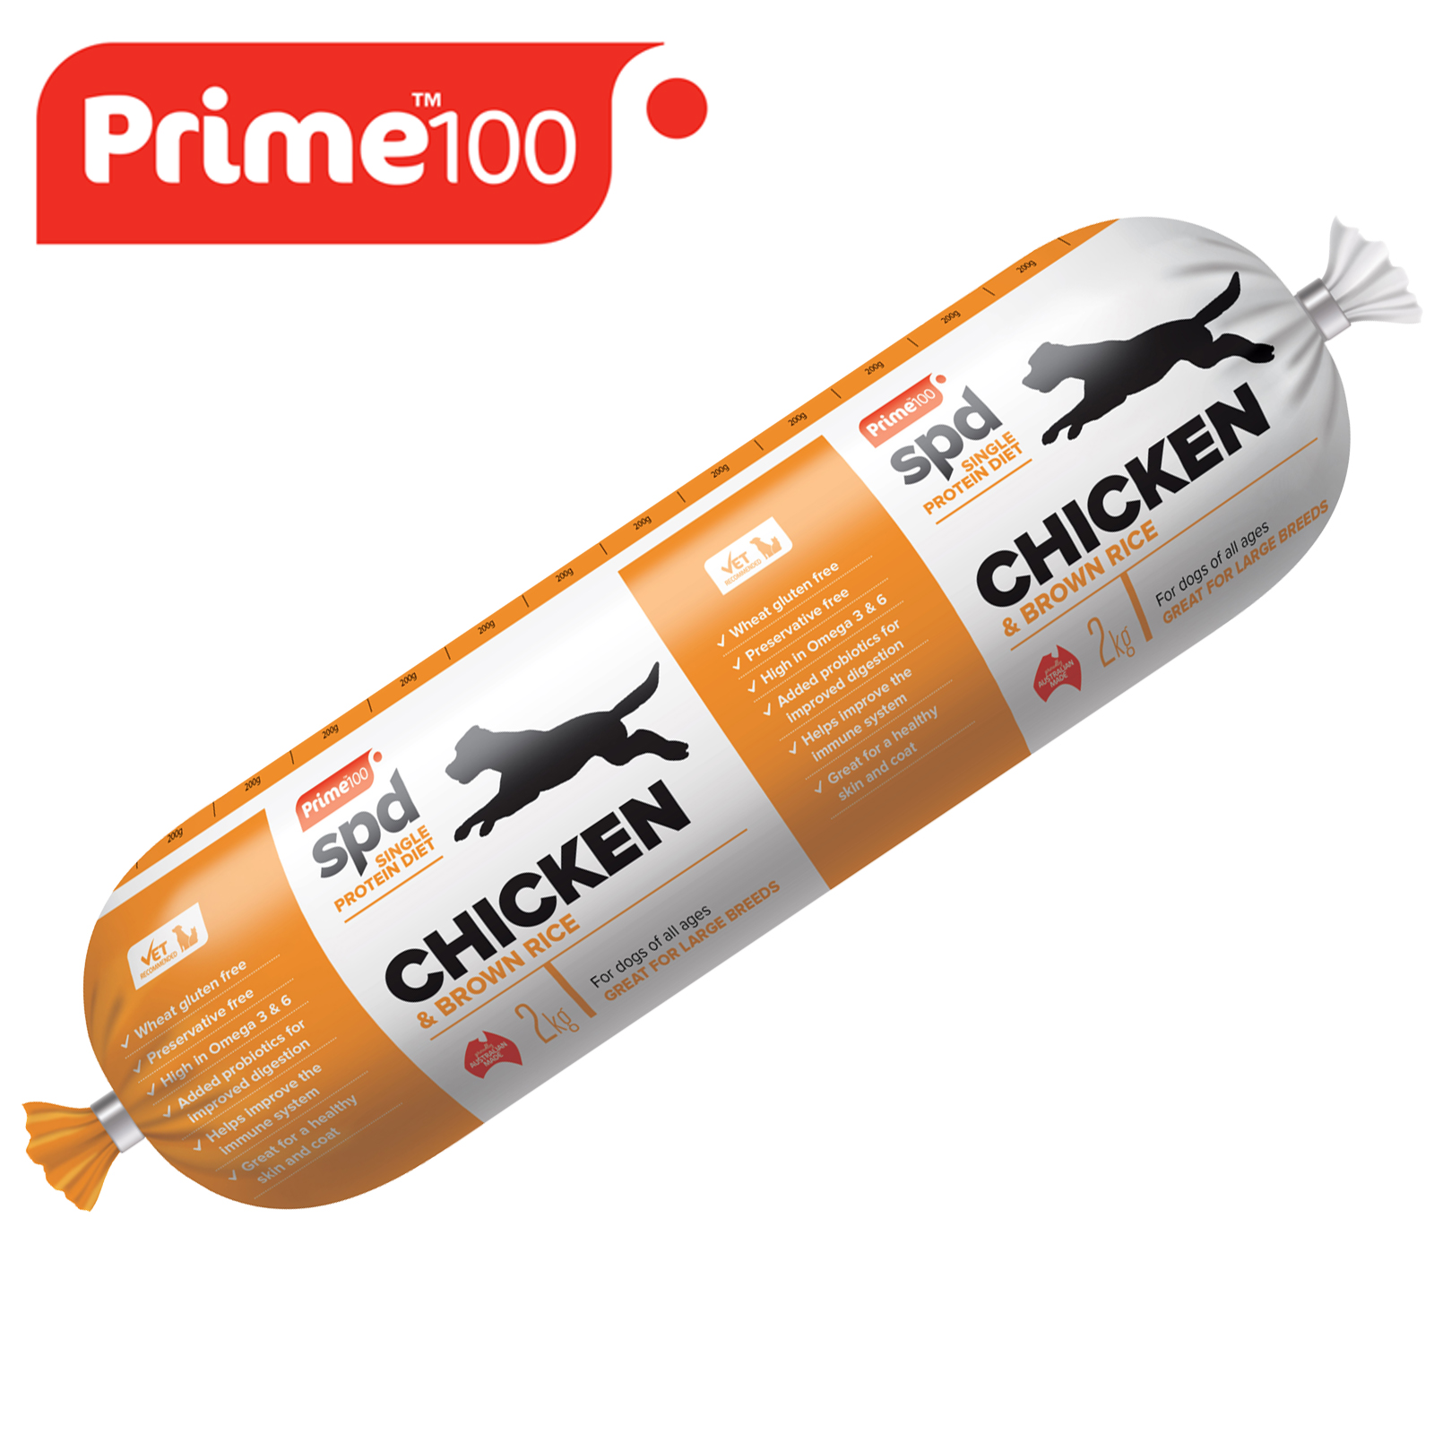

**Prime 100 Chicken & Brown Rice Dog Food Roll 2Kg**

Prime Chicken and Brown Rice is an excellent source of protein and can be purchased through Coles Supermarkets, Woolworths and online stores. Refer to our Puppy Feeding Chart for amounts depending on weight and age.

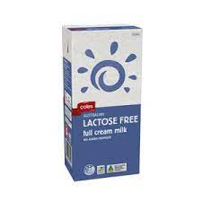

**Lactose Free Milk and Water**

Give your puppy 250-500ml of lactose free milk in a bowl TWICE daily until puppy is 12 months old.

ALWAYS ensure your puppy has access to fresh water.

Provide a separate bowl for water.

**Dry Food**

Give your puppy 2-3 handfuls in a bowl each day around midday.

If uneaten within a day throw it out.

We use Variety Shapes from [Upmarket Pets](https://upmarketpets.com.au/products/variety-shapes-20kg)

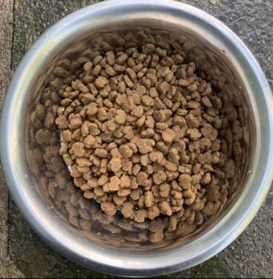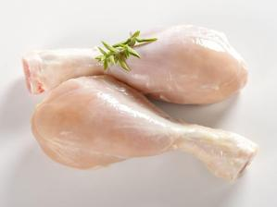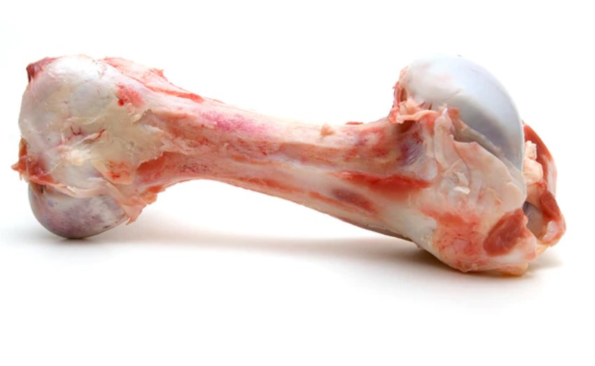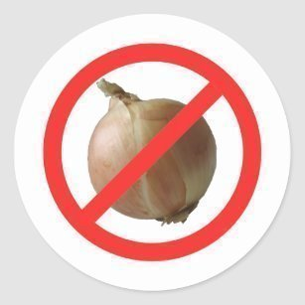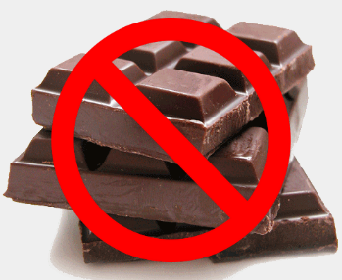

**Raw Chicken and Beef Bones**

From 12 weeks of age give your puppy one raw chicken wing/drumstick or frame every couple of days. It is also important to give your dog raw beef bones on a regular basis for maintaining dental hygiene.

**WARNING**

Never feed your dog chocolate or onions.

Both contain ingredients that are Highly Toxic to dogs!

If you suspect your dog has eaten either of these contact your vet immediately.

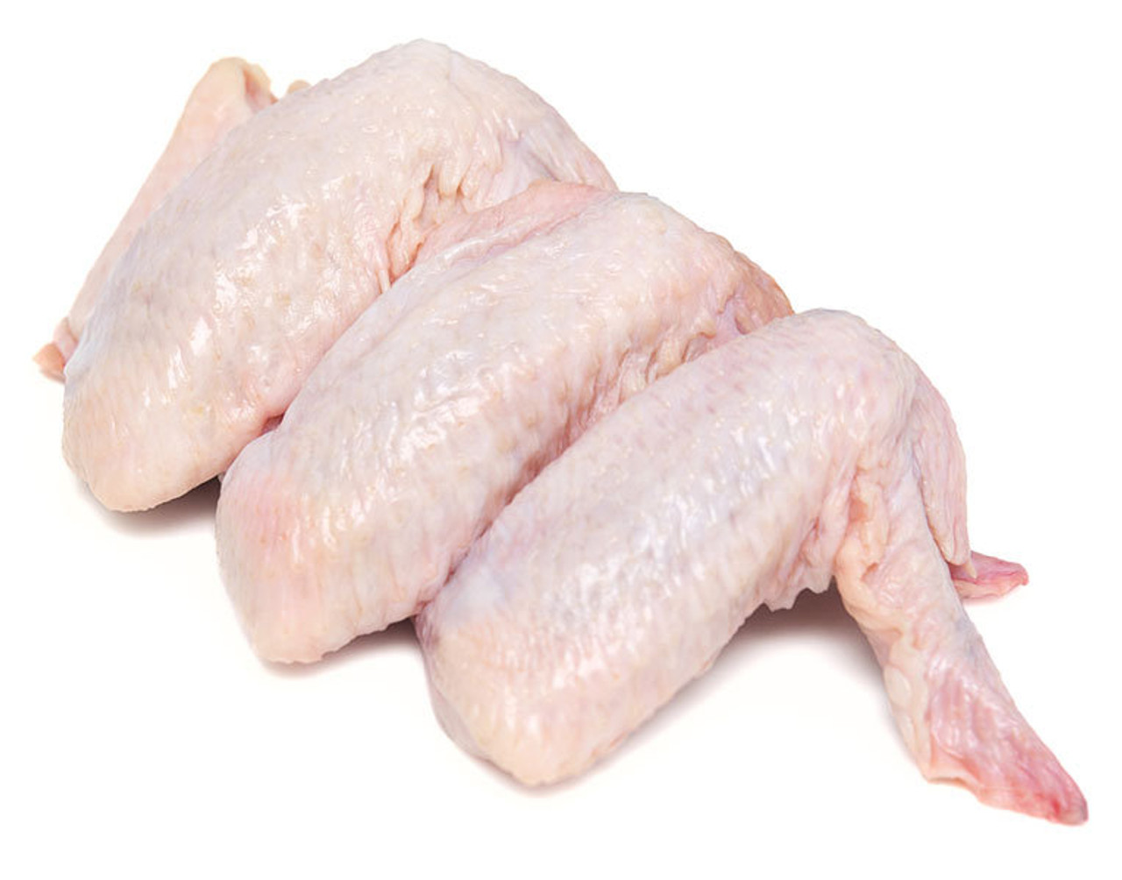

**Raw Chicken and Beef Bones**

From 12 weeks of age give your puppy one raw chicken wing/drumstick or frame every couple of days. It is also important to give your dog raw beef bones on a regular basis for maintaining dental hygiene.





**Maintaining ideal body condition is key to encouraging proper growth in all puppies. View our Puppy Food Chart for amounts based on age and weight. The indicated amounts are only a guideline. If your puppy becomes overweight, a reduction of your puppy’s daily food intake may be appropriate.**

**As puppies near adulthood, their calorie needs may drop, and your puppy may begin leaving some food in the bowl. Don't misinterpret this as an indication of dislike for the food. Instead, begin offering less so your puppy doesn't overeat and stays in ideal body condition.**

**View the** [Your Dog’s Weight and Body condition](https://www.puppiesdownunder.com/dog-weight-and-body-condition) **page for more information.**

**WARNING**

Never feed your dog chocolate or onions.

Both contain ingredients that are Highly Toxic to dogs!

If you suspect your dog has eaten either of these contact your vet immediately.